HR Employee Survey Response

The Datset, “HR Employee Survey Response” I have taken from Kaggle.Dataset.com (Date Created: 31/01/2026)
About:
The Dataset contains the response that have been recorded by HR Department from the employees of four positions(Manager, Staff, Supervisor, Director).
In SQL, I have identified the count of response got from the Employees on each role and also I have able to find around 163 Persons where didn’t completed their response.
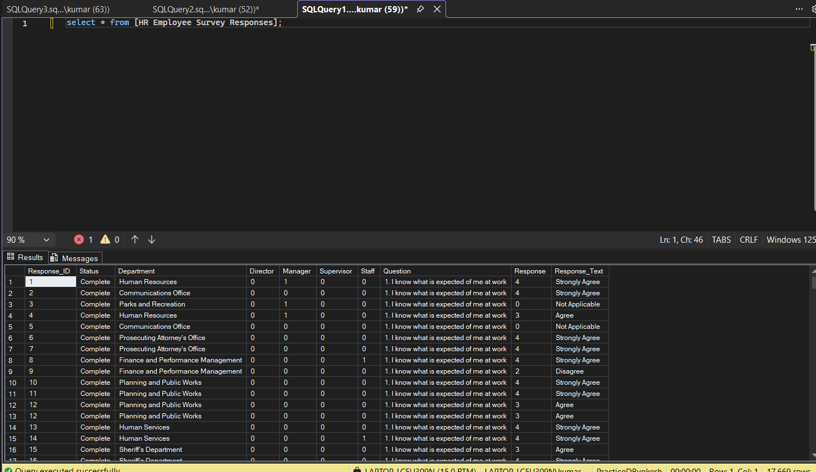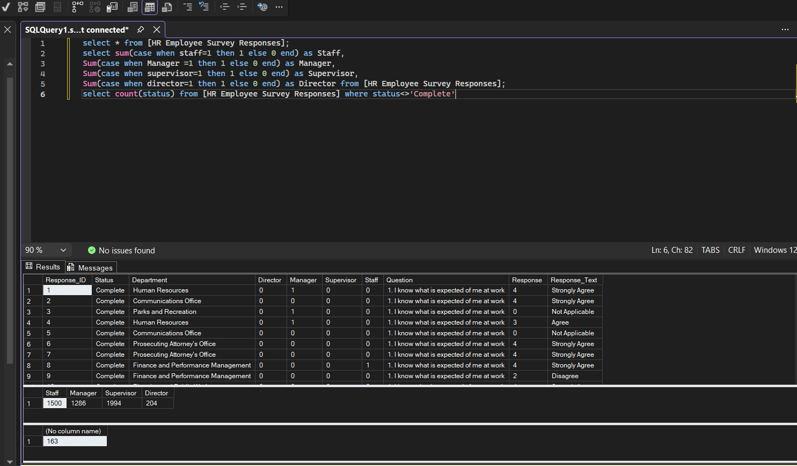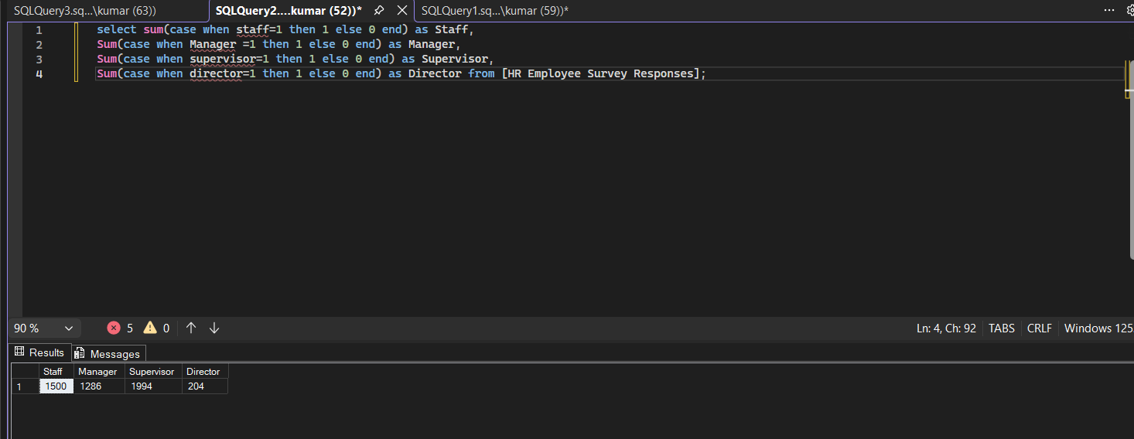
Similarly in Python, (Google Collab), I have did the same as I need to know the basic concepts here(in python) as well to perform the Machine Learning Operation in Upcoming Days.
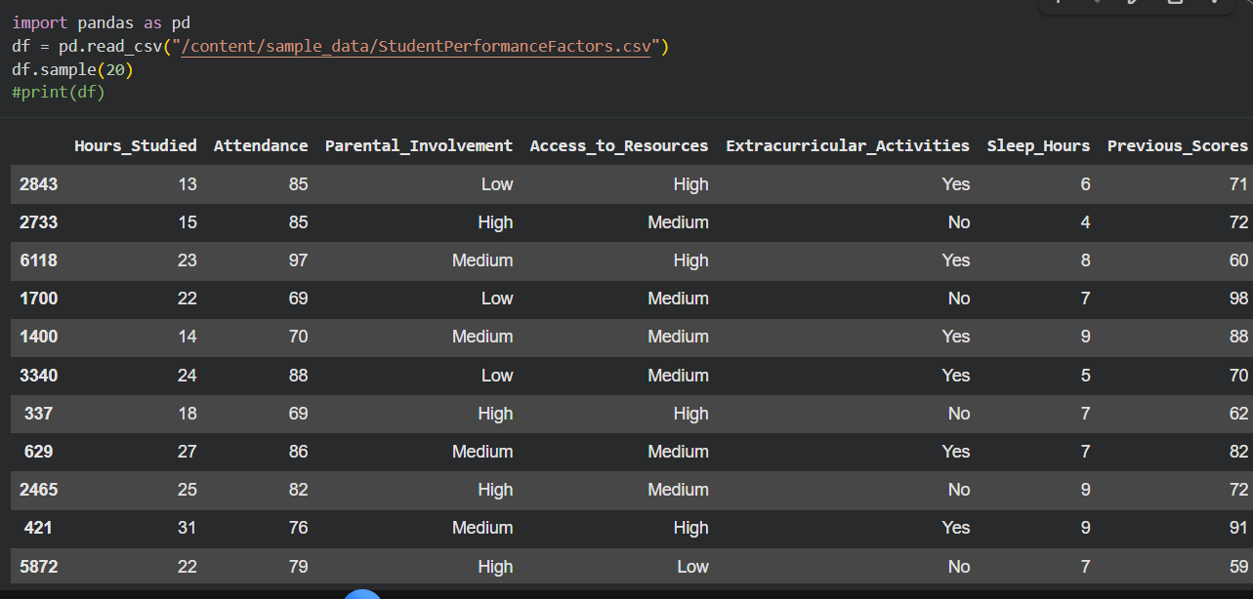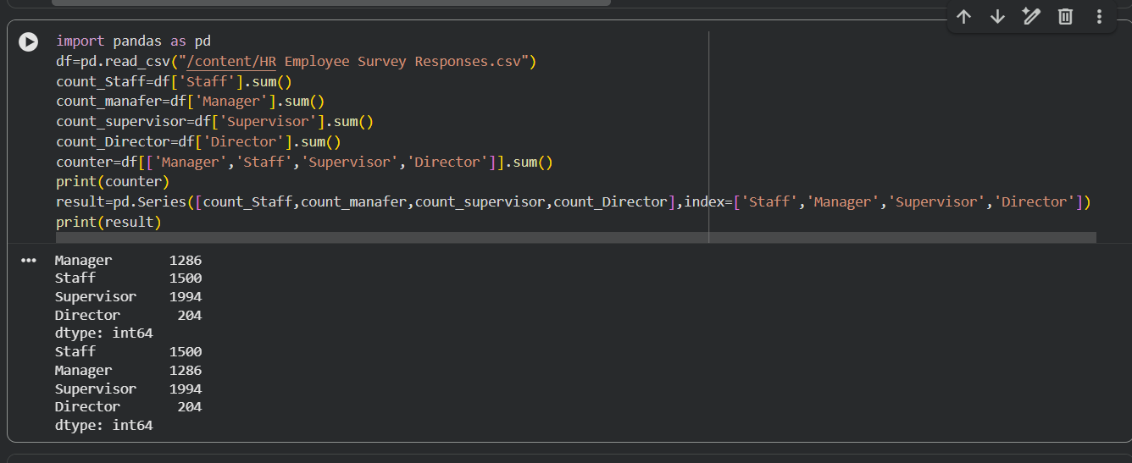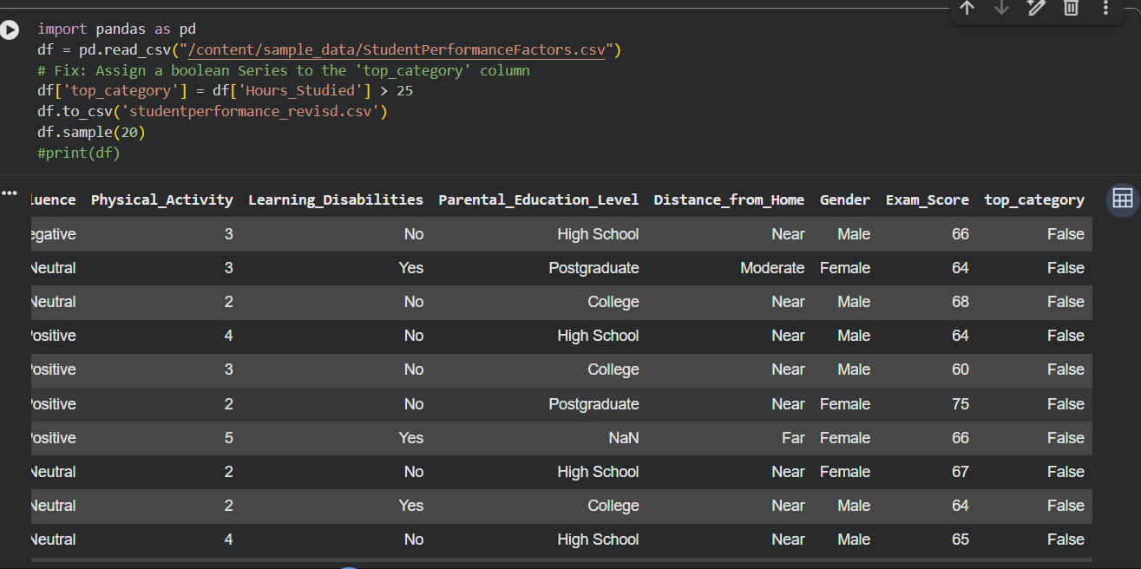

After this to get more insights, I have planned at which department the director is present, so i compiled this code and came to know that Director is present in “Exec Office & Directors” Department.

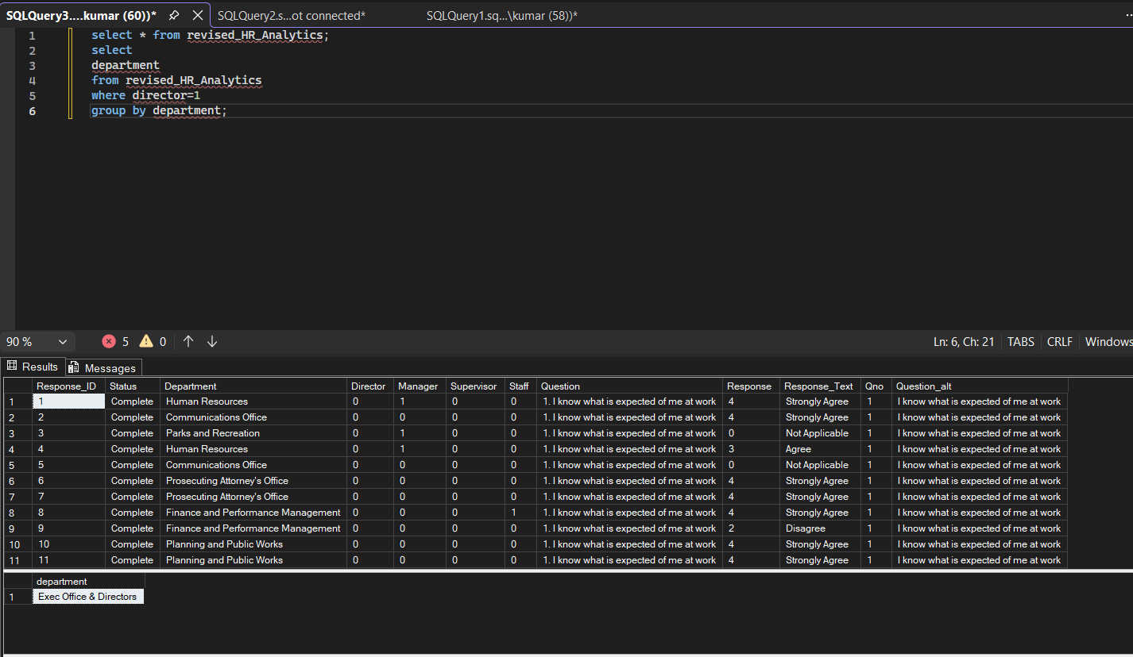
And in Finance and Performance Management we have a average of 13 response given by manager as for the each question the response . So, to make everyone aware I used windows function there(just for fun, I used there to brush up my concept). The purpose to do this is client(my mind) requested me to want the information particularly from Finance and Performance Management, to know there mindsets.
So, we go with managers, first here we take count as 13 managers in department(calculated based on average of response) and we have noted the average of marks for each question and average of total(in department).
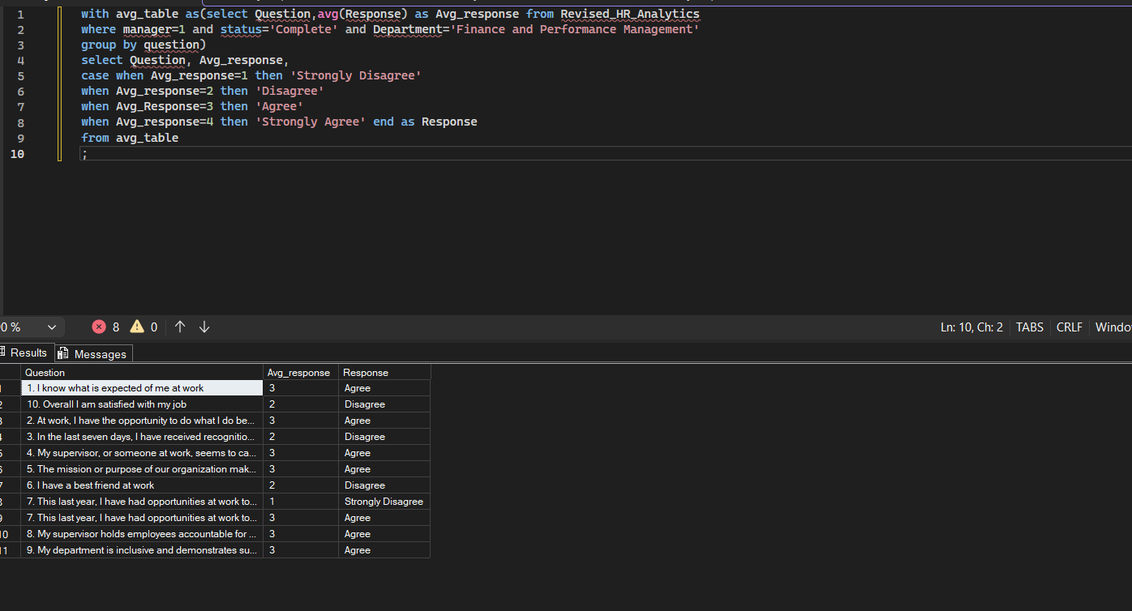
And also to know the staff’s mindset in workplace, as it helps organisation to plan their approach here is the data we got:
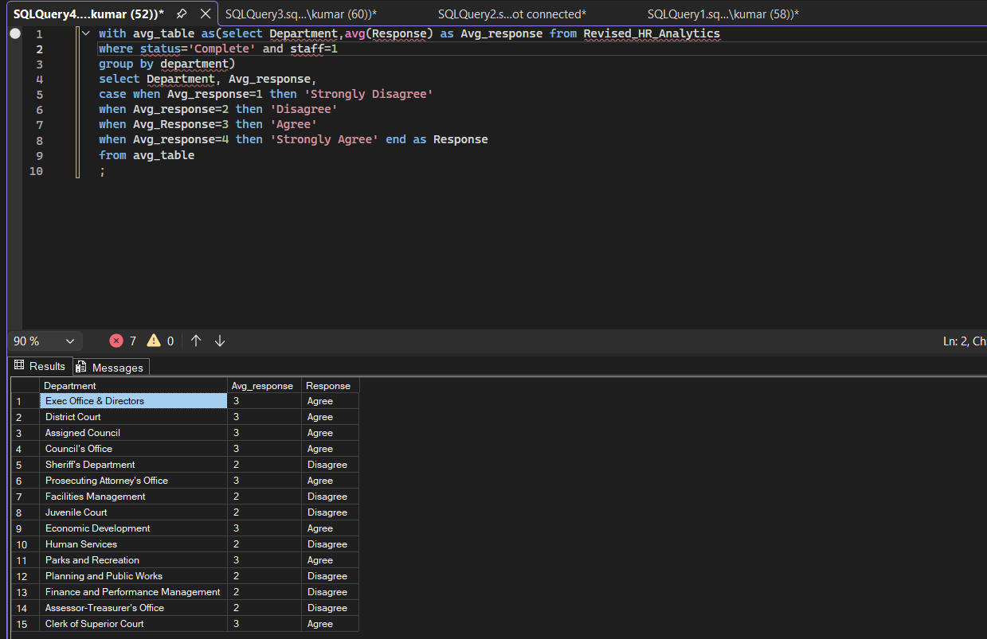
For now, we close this dataset, so if any data required in future we may enter the details here and make it as a tracker(Date of modified). We will do the same in python(to brush up our pandas and numpy concepts) later.
Hi today(1/2/2026), we came back to the project to get the insights using python(ML its for you). So I decided to get the insights as our client said they need comparison of response rating between Managers and Other staffs they belong to finance Department. So to proceed:
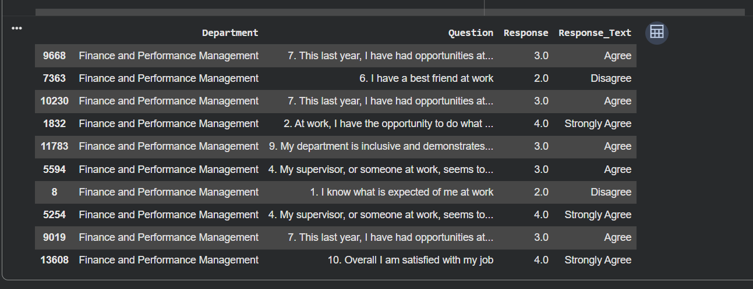
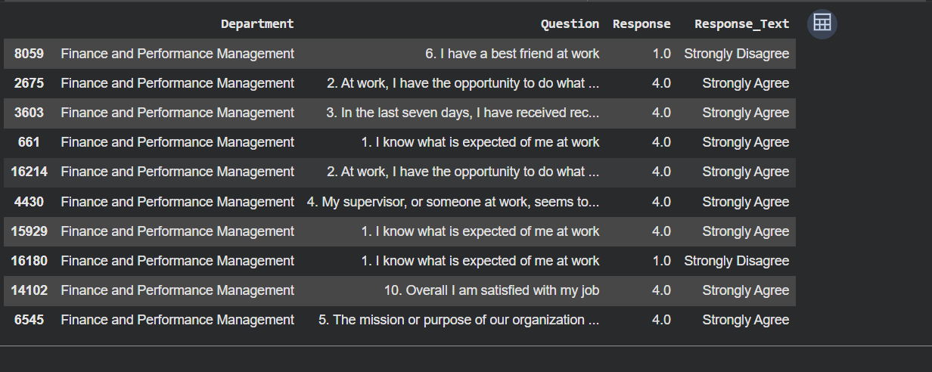
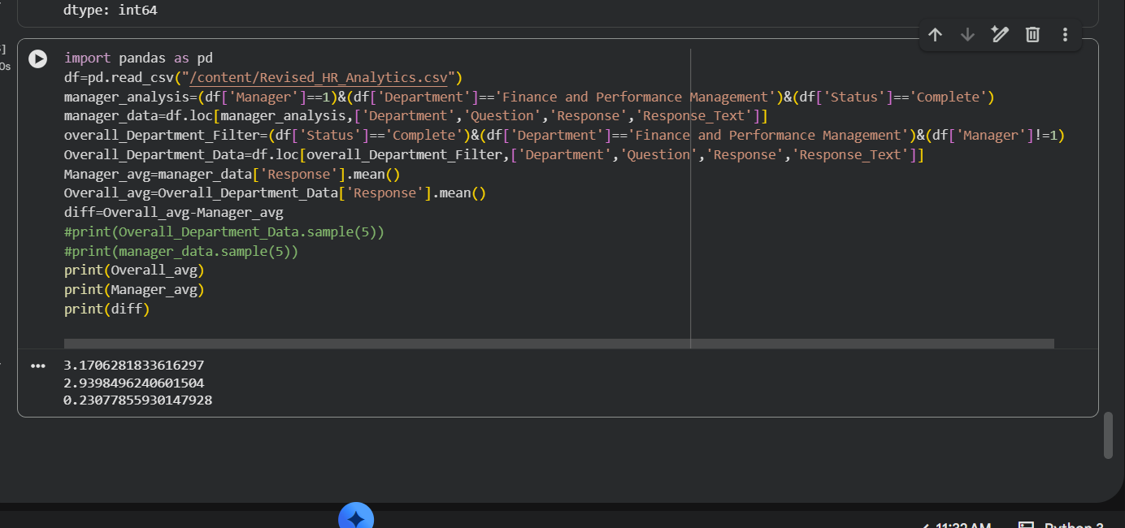
- We imported the data to Google Colab Environment, read the file(stored in Dataframe.
- Then we filtered the manager data based on the condition and found the location that satisfies the condition,
- Then we did the same for getting the overall Department data, and we found the average of 3.1706281833616297 2.9398496240601504 0.23077855930147928.
- First one is Overall Department and next one is average reating of manager aand third one is difference.
- Although if we round of those two we can see same number,but with this average can tell that other employees(except director as they are not present here) were doing there work happily compared to the manager, as I think thy were getting pressure from their Higher officials but doesn’t reflecting their pressure to employees(which is a good thing).
- But we should also take care of Managers as well as this slight dip should still reduce between them.
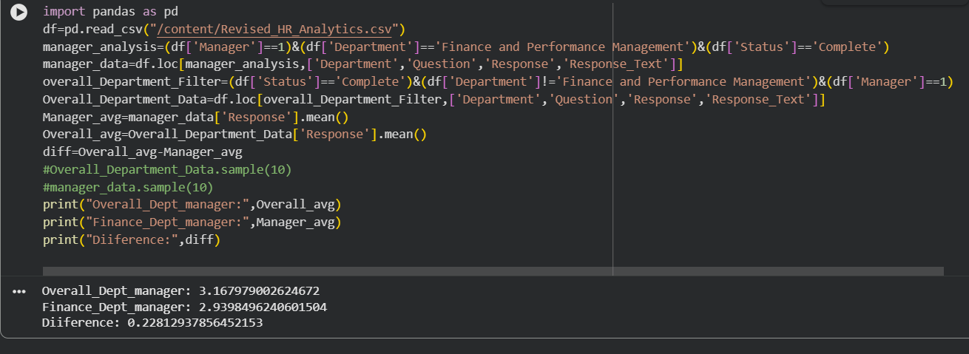

And to make whether the managers from other department were facing these issue, we also analyzed the rating average between Managers from finance Department and managers from other department and we found:

- Yes, similar to previous case the other department managers were happy with the work, compared to Finance managers, as it clearly indicates that finance managers were handling more pressure than Other managers.
- Care has to be given to the manager to handle their stress, as if we failed to take care then the difference between them will increase in upcoming surveys.
You may see now the values have been mapped with names,(previously I forgetted to place this name and to accept I have placed ‘+’ symbol instead of ‘,’. When we are going to advance concept, we should remember the basic concepts as well(laughs while typing this…).
Lets move on..
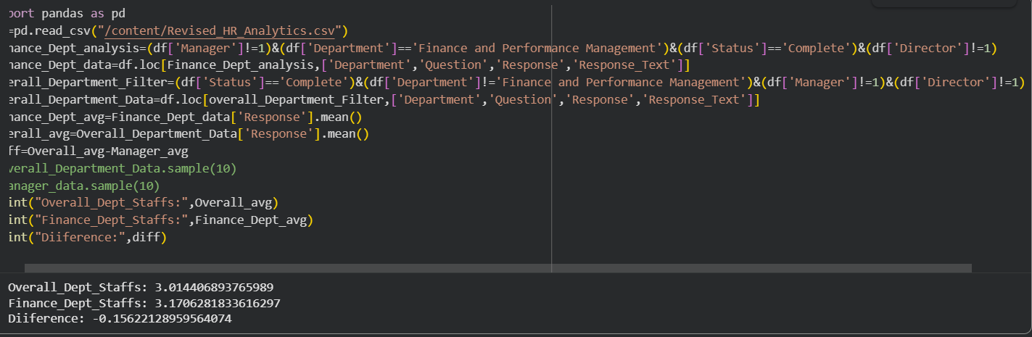
After seeing this screenshot, you guys may have shocked(same feeling here),because the employees(other than Finance Dept) are less happier compared to staffs in finance Department(see the difference). I think it is due to the managers(Finance Department) intakes the pressure of employees too.. Care has to be given to employees of other department.
Till now this are all the requirement given by client(as they pimarily wanted to focus on finance Department related data). If client(it is my mind with laugh) asks to do analyse on the other departments I am ready to do it. Ok for our concept brush up lets get the overall rating average of the each department(we need to understand the group by in python also right).
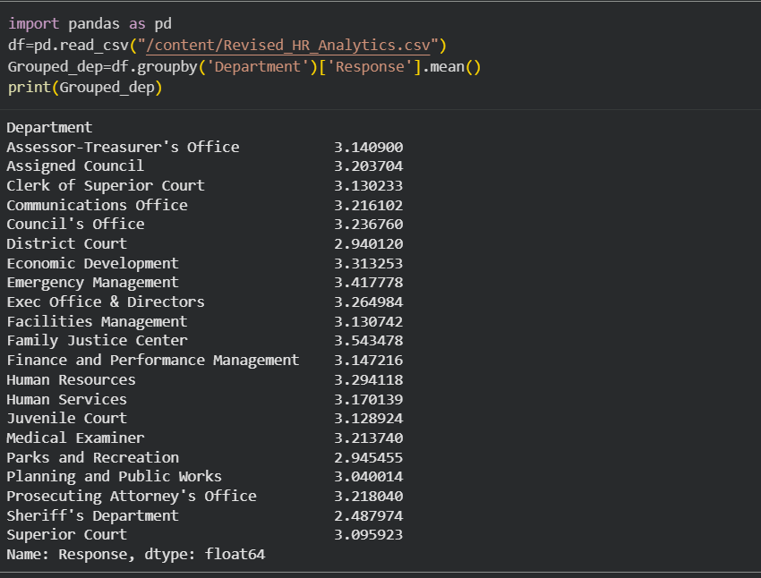
Ok, from this we can see that there are many department’s rating average is lower than Finance and performance Department(especially see Sheriff's Department). I think it is police Department or something else. I will ask my client(my mind) permission and analyze that department especially to improve their happiness(rating average) as like Emergency Department.
You may ask why are showing only text data not visually like that I can understand. The problem is that I don’t know as of know(laughs). I am happy if you guys know. So I will learn it once and come back stringer to perform our future task(analyze the sheriff’s Department especially once my client grant the permission) and also I will learn the visualization(I know in pandas also visualization present but we learn matplotlib also to get better visuals). Ok we will continue with even better when we come back later.

